Group Members:
- Ali Asghar (2059)
- Shahad Bangash (1980)
- Suleman Shah (1983)

- Entity Descriptions:
Customer | A customer or organization that can book any number of halls and submit reviews.
Hall | A hall that can be booked by customer and must have an assigned owner and manager.  It can be of two types, wedding hall or conference center.
Manager | A manager is responsible for managing the operations of its associated hall.
Invoice | An invoice must be generated for each booking, detailing the payment information, the customer who booked, and the hall that was booked.
Review | Reviews may be submitted by customers, providing feedback on their experience with the booked hall.
Owner | An Owner of its specified hall.

- Business Rules:
- A customer can book one or more halls for events. A customer may submit reviews for each hall they book, providing feedback on their experience.
- Each hall can be a wedding hall, conference hall or an event hall. Each hall must have exactly one assigned owner. Each hall must have exactly one assigned manager. A hall can be booked by multiple customers over time.
- A manager is responsible for the day-to-day operations of the hall they are assigned to. A manager ensures that the hall is properly maintained and ready for use by customers.
- An invoice must be generated for each hall booking. The invoice has details about payment, time of booking, customer details.
- Customers are encouraged to submit reviews after their event. Reviews should provide honest feedback about the customer’s experience with the hall. Reviews are used to assess the quality of service and identify areas for improvement.
- Owner is responsible for the overall property and condition of the hall. The owner may delegate day-to-day operational responsibilities to a manager but retains ultimate accountability for the hall.
- ERD:
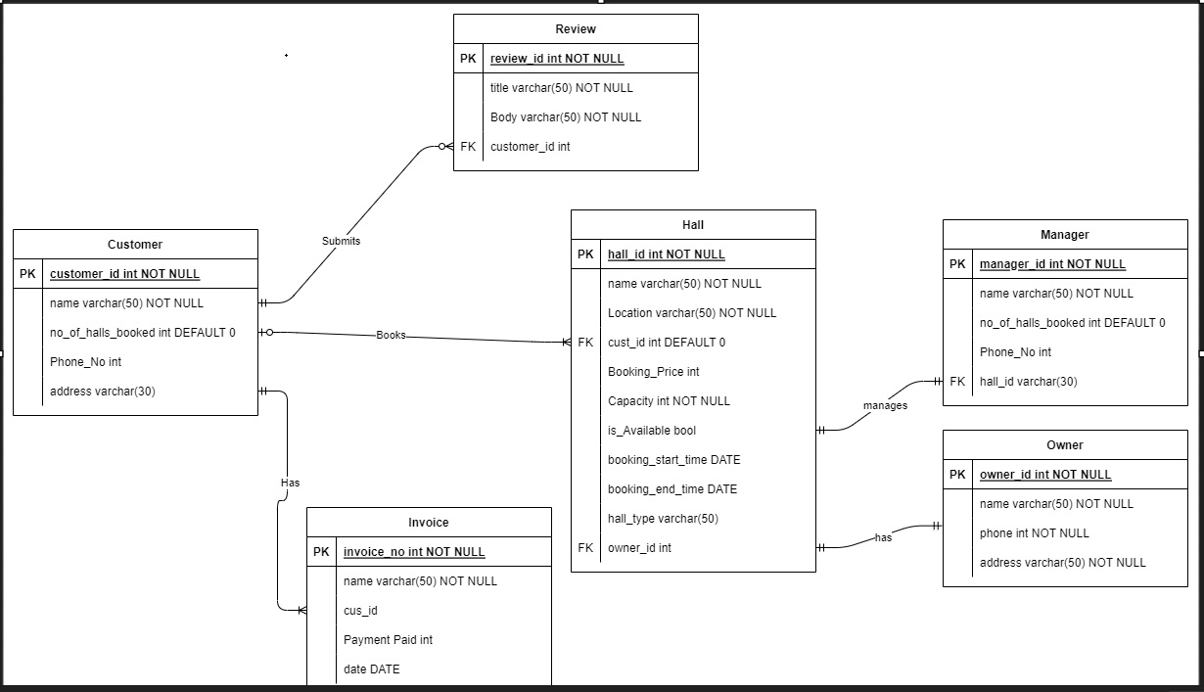

- References:
Lecture 2a
Lecture 2b
Our Knowledge and Understanding of the subject.
ChatGPT

